Web Crawler

Project report submitted in partial fulfillment of the Requirements for the
Award of the Degree of B.Tech in Computer Science and Engineering

BY

Kartikeya Agarwal-2012762
Aradhya Mishra-2012513
Abhishek Bhatt-2012465

Under the Guidance of

Mr. Saurabh Mishra



Department of Computer Science and Engineering Graphic Era Deemed to be University
Dehradun-248002 2021

CERTIFICATE

This is to certify that the project report entitled WEB CRAWLER being submitted by

Kartikeya Agarwal-2012762
Aradhya Mishra-2012513
Abhishek Bhatt-2012465

in partial fulfillment for the award of the Degree of Bachelor of Technology in Computer Science and Engineering (or Information Technology) to the Graphic Era Deemed to be University is a record of Bonafede work carried out under my guidance and supervision.
The results embodied in this project report have not been submitted to any other University or Institute for the award of any Degree or Diploma.

Mr. Saurabh Mishra
Project Guide Head of the Department

ABSTRACT

The present idea discloses an idea to build a crawler or bot which could crawl over web pages efficiently. Information gathering is an essential phase for collecting important and relevant data to carry out security tests or penetration testing. Information gathering is a time-consuming and laborious phase for which there are special automated tools to ease the gathering of information, producing more efficient results. These tools or programs are called web crawlers. When the crawlers visit a website, they search for other pages that are worth visiting. Web crawlers can link to new sites, note changes to existing sites and mark dead links. The web crawler looks at the keywords in the pages, the kind of content each page has and the links, environment of the target, versions and software used by the target before returning the information. Searching for the domains related to the websites along with the links associated with it and URL validation.

Keywords: Web Crawler, Information gathering, domain, URL validation.

 |  | TABLE OF CONTENTS
Contents
1 | Introduction |  | 6
2 | Literature Review |  | 6
3 | Problem Statement |  | 7
4 | Objective |  | 7
5 | Design Methodology |  | 7
6 | System Requirements |  | 8
7 | Schedule Pert Chart |  | 9
8 UML Activity Diagram |  |  | 9
9 UML Sequence Diagram |  |  | 10
10 Implementation |  |  | 11

List Of Figures

Figure | Page No.
UML Activity Diagram | 9
UML Sequence Diagram | 10

1 Introduction

Information gathering is the very first phase of any penetration testing or vulnerability assessment. It is an act of collecting information from various sources. It is hard to collect data or information from millions of sources therefore web crawlers or bots or spiders are used.

To find information on the hundreds of millions of Web pages that exist, a search engine employs special software robots, called spiders, to build lists of the words found on Web sites. When a spider is building its lists, the process is called Web crawling. The term crawling literally means scanning through any piece of text, be it links to other websites, image captions, descriptions, articles, anything. It's like a spider searching through the web.

A crawler is a program that visits Web sites and reads their pages and other information in order to create entries for a search engine index. Web Crawlers collect information such as URL of the website, meta tag information, links in webpage, content of the webpage

- Literature Review

According to P Boldi, Web crawlers help in collecting information about a website and the links related to them[2].

There are many research papers and media articles written on the importance of web crawlers. C Olston in his paper talks about how efficient web crawling is important while describing the practices of a web crawler [3].

Sergey Brin in their article[4] says that the crawler is designed to crawl and index the Web efficiently and produce much more satisfying search results

- Problem Statement

Information gathering is the most important and time-consuming task which needs to be done before any security testing or penetration testing. To reduce this time and improve the efficiency of searching along with producing relevant information of the target, a web crawler is developed which ease this laborious phase.

- Objective

The objective of this project is to develop a tool which could crawl websites and help in information gathering process of VAPT.

The sub-objectives of the project are:
1. To ease the task of information gathering.
2. To fetch relevant data efficiently.
3. To use different user-agent strings to find more content.

- Methodology
For the optimal design, planning, implementation and achievement of the project objectives, waterfall model is being used. It is a sequential model with each phase dealing with series of tasks and distinct objectives. By separating the set of concerns, the large and complex task of building the software is broken into smaller tasks which make it easier to handle.

The project is divided into four main sections:-

1.Requirement Analysis
1. Studying the existing techniques and journals published on web crawlers
2. Assessment of the requirements of the project
3. Defining the scope of the project

2. Design and development of prerequisites
1. Defining the various use cases of the project
2. Preparing the data flow diagram of the project
3. Preparing the various modules of the project- parsing URL, implementing user-agents, linking web pages, indexing, implementation and unit testing.

3. Implementation & unit testing
- Creating the modules language.
- Testing each module separately.
- Integrating the modules

4. Testing
- Testing the integration of modules
- Testing the System.

6 System Requirements

Hardware:
- 8 GB Ram
- Intel Core i5 64 bit Processor
- Input and Output Devices
Software:
- Windows 10 1903 64 bit
- Python 2.7

8. Activity Diagram

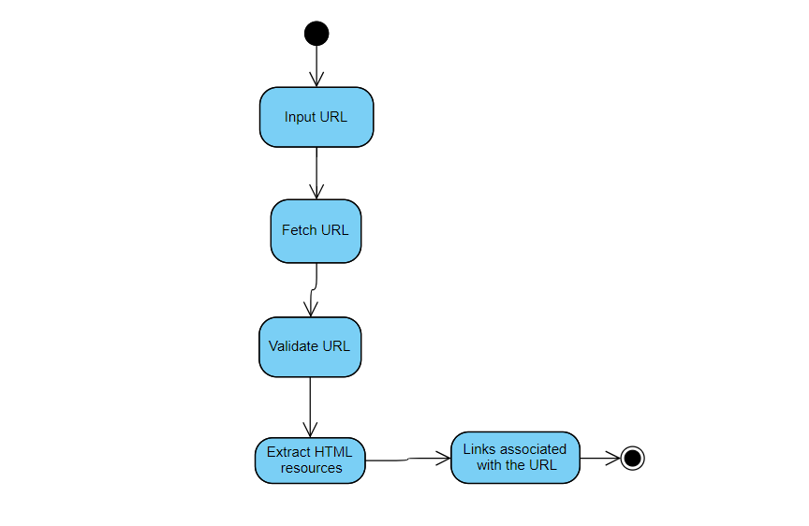

Figure 2- Activity Diagram

9. UML Sequence Diagram
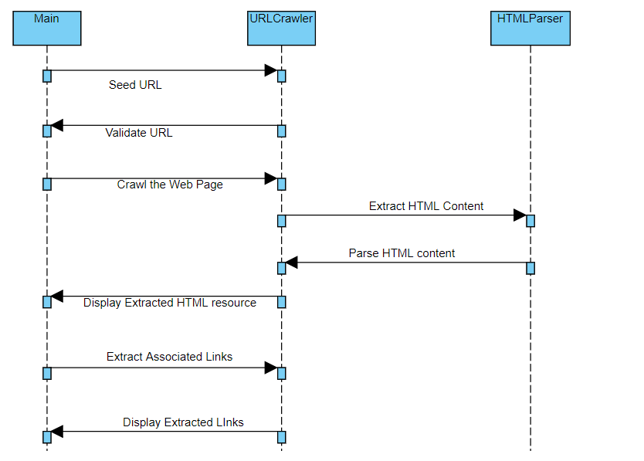

Figure 3- UML Sequence Diagram
Implementation

10.1 Pseudocode
- Initiaization
- Get input URL
url = input("What is your url? ")
- Fetching URL
  - requests.get(url)
- Validate URL
- Extract and parse HTML content
  - html=urlopen(url)
  - soup = BeautifulSoup(html, 'lxml')
- Extract Links associated with the URL
  - all_links = soup.find_all("a")
  - for link in all_links:
  - print(link.get("href"))
- Get Domain Name
- try:
- results = get_sub_domain_name(url).split('.')
- return results[-2] + '.' + results[-1]
- except:
- return ' '

10.2 Output Screen

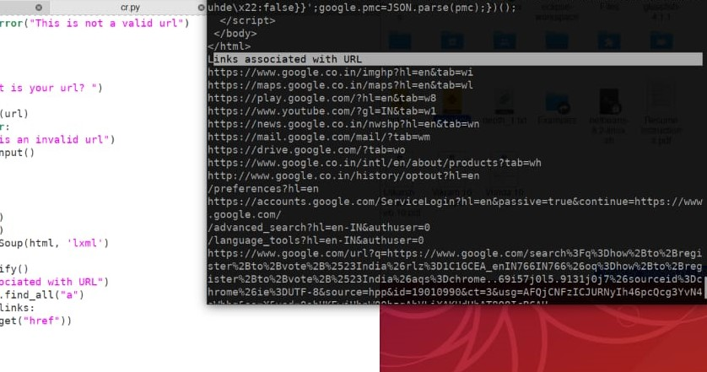

Output 1: Extracting the links, domains and other information related to the website.

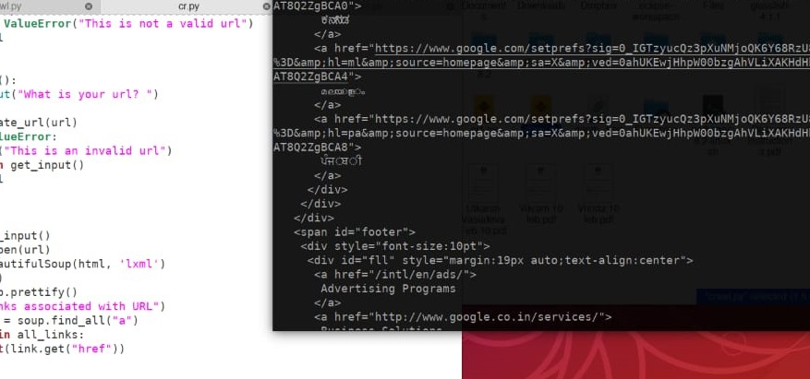
Output 2: Extracting the HTML content and tags of the Target website

10.3 Result Analysis
We have successfully completed the development of a web crawler which serves the purpose of information gathering by gathering the HTML content, tags, domains, sub-domains, links associated of the target website along with URL validation for meeting security purposes.

References
[1] Carlos castilo , “Effective web crawling”, Department of Computer Science and Technology, University of chille, 2005.

[2] P Boldi, M Santini “Ubicrawler: A Scalable distrubted web crawler”, Wiley Library (2004).

[3] C Olston, “ Web Crawler”. Foundations and trends in information retrieval, 2010.

[4]Sergey Brin, "Anatomy of large-scale hyper textual web search engine ", Lawrence page, 2012

APPENDIX I Source Code

import requests
import urllib.request
from bs4 import BeautifulSoup
from urllib.parse import urlparse

def get_domain_name(url):
try:
results = get_sub_domain_name(url).split('.')
return results[-2] + '.' + results[-1]
except:
return ''

def get_sub_domain_name(url):
try:
return urlparse(url).netloc
except:
return ''

def validate_url(url):
if not "http" in url:
raise ValueError("This is not a valid url")
return url

def get_input():
url = input("What is your url? ")
try:
validate_url(url)
except ValueError:
print("This is an invalid url")
return get_input()
return url

def main():
url = get_input()
with urllib.request.urlopen(url) as response:
html = response.read()
soup = BeautifulSoup(html, 'html.parser')
type(soup)
print (soup.prettify())
print("\nDomains Associated with the URL:\n")
print (get_domain_name(url))
print("\nLinks associated with URL\n")
all_links = soup.find_all("a")
for link in all_links:
print(link.get("href"))

main()

